朝陽科技大學補助研究生出席國際會議申請表
Chaoyang University of Technology (CYUT)
Application Form for Students Attending International Conferences Subsidy
申請人姓名  Name of Applicant |  |  |  |  |  |  | 性 別  Gender |  |  |  | □男M □女F
學 號  Student ID No. |  |  |  |  |  |  | 指導教授  Supervisor
系/年級/班級  Department/ grade/class |  |  |  |  |  |  | 學 制  Degree |  |  |  | □博士班 Doctoral program  □碩士班 Master’s program  □五年一貫 (請附證明)  Five-year program (Please submit with certification)
連絡電話  Phone number |  |  |  |  |  |  | E-mail
會議起訖時間  Conference date |  | 自From_____/______/____ 至to _____/______/____ (YYYY/MM/DD)
會議地點  Location |  | 國家  Country |  |  |  | 城市  City |  |  |  |  |  | Scopus  (within 5 years) | □Y (請附證明)  □N
會議名稱
Conference name
會議主辦組織
Conference host
發表論文題目
Title of the paper presented
作者順序/作者人數  Author order / number of authors |  | 第 作者/共 人  The __ author/ __ author(s) in total |  |  |  |  | 發表方式  Presentation mode |  |  |  | □口頭發表 Oral  □壁報發表 Poster
申請補助項目  Amount requested |  | □機票費(Airfare)，新臺幣(NT$) 元  □註冊費(Registration fee)，新臺幣(NT$) 元
※請申請人就下列逐項檢核，未勾選不予受理
Please check each of the following items. Without doing so, the application will not be accepted.
1.以本校名義發表論文  Publish paper with the name of Chaoyang University of Technology. |  |  |  |  | □是Yes |  |  | 申請人簽章：  Applicant’s signature
2.本人未獲其他單位經費補助  I receive no subsidy from other agencies. |  |  |  |  | □是Yes
指導教授簽名  Signature of supervisor |  |  |  | 系所主管簽章  Department Head |  |  |  |  |  | 學院主管簽章  College Dean
研究發展處  R&D Office | 收件時間  Received date |  |  |  |  |  |  | 核准補助總額  Approved subsidies
個人資料蒐集告知內容：為辦理研究生出席國際會議補助之目的，需蒐集之姓名、性別、電話、E-mail、學號等個人資料(識別類：C001辨識個人者、C057學生紀錄)，於提出申請至結案期間於校務地區進行必要聯繫及學籍資料確認之用，若未提供正確完整資料，可能對您的權益有所影響，您得依個人資料保護法第3條行使查閱、更正個資等權利，行使方式請洽研發處計畫組(分機3282)。
In order to process students attending international conferences subsidy, the personal data collected in this form (Including name, gender, phone, email, student ID number and etc.) for verification purposes. Applicant must exercise his/her right to ensure all personal data is accurate as providing false or incomplete information may result in rejection of the application. For more information, please contact R&D Office (Ext. 3282).
一、申請方式How to apply
請於出國前至少2周之前提出申請，申請時檢附：
1.申請表。(word/odt檔上傳
2.大會正式邀請函或論文被接受之證明文件。
3.論文摘要及全文(若有本校學生共同發表之情況，需檢附其他學生作者同意文件)。
4.國際會議日程表(若尚未公告日程者，則檢附徵稿啟事)。
5.國際會議需於5年內曾收錄scopus之證明。
(https://www.scopus.com/search/form.uri#basic-->會議，去除年度後搜尋)
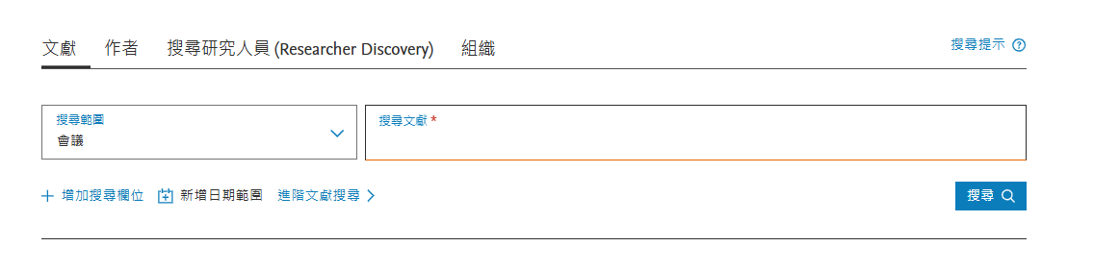
The applicant shall submit the following documents to R&D Office at least TWO weeks before departure.
- Application form
- Official invitation letter or paper acceptance letter
- Abstract of paper presented (In the case of publishing with our university’s student co-authors, please submit the agreement form from other student co-authors).
- Conference agenda (If unavailable, please submit the ‘call for papers’)
- International conferences require proof of having been included in Scopus within 5 years. (https://www.scopus.com/search/form.uri#basic--> conference, Search after removing the year)
二、回國後繳交心得及辦理結案 After returning to Taiwan
回國2週內請送以下資料（憑證勿黏貼）至研發處辦理。
1.已核准之出差請示單。
2.出差旅費報告書（需於出差人欄簽名並經系所核章）。
3.申請「機票費」補助：
(1)電子機票；
(2)機票購票證明或旅行業代收轉付收據；
(3)登機證；
(4)已核准之搭乘外國籍航空公司班機申請表（若搭乘本國籍航空公司班機則免）
4.申請「註冊費」補助：
(1)註冊費收據；
(2)外幣請以出國前一天臺灣銀行即期匯率-賣出計算（若台幣單位則免）
5.心得報告。
6.論文（依指導教授帳號）上傳本校機構典藏系統完成之截圖，並繳交指導教授簽署之「朝陽科技大學機構典藏授權同意書」至圖資處採編組。
Please submit the following documents (Do not use glue) to R&D Office within TWO weeks after return.
- Approval Application form for Work Trip
- Work Trip Expense Report (with applicant’s signature and department head’s stamp)
- Apply for airfare:
  - Electronic ticket (E-ticket)
  - Airfare purchase proof or travel agency receipts
  - Boarding pass
  - Application form for Taking Foreign Airline Flights for Work Purposes (if applicable)
- Apply for registration fee:
  - Registration fee receipt.
  - If registration fee is paid using a foreign currency, the exchange rate will be based on the spot selling rate that provided by the Bank of Taiwan on the eve of departure.
- Report for attending international conference.
- Upload the electronic file of paper to the CYUT Institutional Repository System (by advisor’s username and password) and screenshot the completed record. Submit the Copyright License Agreement with advisor’s signature to Office of Poding Memorial Library and Information Services.

